REQUEST FOR QUALIFICATIONS

INFORMATION REQUEST #1

Commercial Air Service Terminal Project
Airport Authority of the City of Gulf Shores

- Airport CAD Files

The following files are being made available via the below link from the Authority’s consultant Barge Design Solutions.
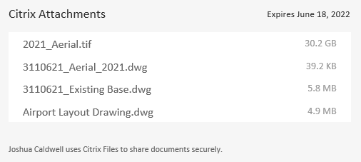
Select Ctrl and click the below link. Note the Aerial is a very large file.
Download CAD Files
Download Attachments

- Airport Financials

Appendix 1 now includes FY 2019, 2020, and 2021 (pre audit).
- Cost per Enplanement (CPE) and Benchmarking
The following table shows enplanements, passenger airline payments, CPE, and total debt outstanding at four of the neighboring airports to JKA.
 | 2015 | 2016 | 2017 | 2018 | 2019 | 2020
MOB
Enplanements (000) | 290 | 293 | 304 | 305 | 318 | 209
Total Passenger Airline Payments ($000) | 4,021 | 3,985 | 4,078 | 4,057 | 4,098 | 3,812
CPE | $13.87 | $13.61 | $13.41 | $13.32 | $12.88 | $18.26
Total Debt ($000s) | 17,501 | 10,065 | 10,065 | 9,608 | 9,690 | 8,940
PNS
Enplanements (000) | 798 | 802 | 835 | 952 | 1,100 | 693
Total Passenger Airline Payments ($000) | 6,592 | 7,072 | 6,123 | 6,003 | 6,094 | 6,564
CPE | $ 8.26 | $ 8.82 | $ 7.34 | $ 6.31 | $ 5.54 | $ 9.48
Total Debt ($000s) | 66,526 | 63,069 | 60,254 | 59,988 | 50,594 | 48,075
VPS
Enplanements (000) | 385 | 457 | 588 | 680 | 821 | 508
Total Passenger Airline Payments ($000) | 1,922 | 2,230 | 2,545 | 3,008 | 2,190 | 3,126
CPE | $ 4.98 | $ 4.88 | $ 4.33 | $ 4.42 | $ 2.67 | $ 6.15
Total Debt ($000s) | 19,502 | 18,850 | 18,698 | 17,840 | 13,440 | 5,915
ECP
Enplanements (000) | 434 | 443 | 472 | 523 | 603 | 437
Total Passenger Airline Payments ($000) | 2,452 | 2,837 | 2,942 | 2,953 | 2,462 | 4,112
CPE | $ 5.65 | $ 6.40 | $ 6.24 | $ 5.64 | $ 4.09 | $ 9.42
Total Debt ($000s) | 40,942 | 39,736 | 38,474 | 37,154 | 35,774 | 34,330
Source: FAA Form 127 CATS
Note that while CPE is a common metric to compare the relative costs for airlines at airports, it is not a perfect measure as it does not consider the age or efficiency or airport facilities or any facilities funded directly by airlines

The above table utilizes the FAA Form 127 CATS data as reported by the various airports. Some airports may include only the initial fees and charges paid by the airlines, while others may include the impact of any credits, discounts, revenue shares, or other adjustments resulting from airline agreements, incentive programs, etc.
Rating agency reports may provide additional detail on an airport’s capital program, cost trends, management performance, etc.
https://www.fitchratings.com/research/us-public-finance/fitch-affirms-pensacola-florida-airport-revs-at-bbb-stable-outlook-22-09-2016
More recent rating agency reviews may be available via subscription.

